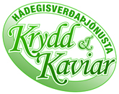
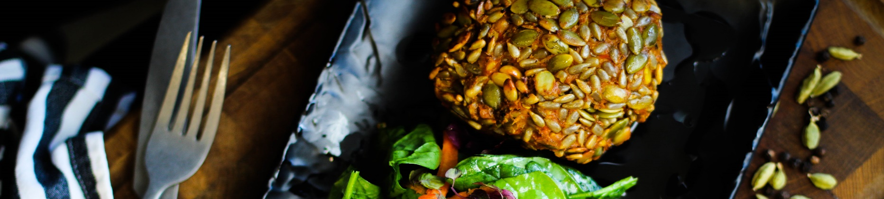
Menu
Week 12.-16. Jan 2025

2024

MMán  Monday | Vegan course: Butternut and splitpea stew Ⓖ Ⓥ Ⓜ  Meat/fish of the day: Lamb tikka masala, rice Ⓖ  Soup of the day: Brokkolisoup Ⓥ Ⓖ Ⓜ  Fresh and healthy saladbar –, chivebread, fresh out the oven
Tuesday | Vegan course: Spring rolls, rice, sweet chili sauce Ⓥ Ⓜ  Meat/fish of the day: Redfish, rice, cauliflower, curry sauce with apples  Soup of the day: Wild mushroom soup Ⓥ Ⓖ Ⓜ  Fresh and healthy saladbar –, sundried tomatobread, fresh out the oven
Wednesday | Vegan course: Mushroom bygotto with balsamic roasted carrots Ⓥ Ⓜ  Meat/fish of the day: Slowcooked brisket in redwinesauce, potato purre, roasted carrots Ⓖ  Soup of the day: pumpkin sweetpotato soup Ⓥ Ⓖ Ⓜ  Fresh and healthy saladbar – cinamon and apple bread, fresh out of the oven
Thursday | Vegan course: Mexican stew with nachos Ⓥ Ⓜ  Meat/fish of the day: Ovenbaked haddock, roasted potatoes with carrots, Onion butterⒼ  Soup of the day: Meatsoup Ⓖ Ⓜ  Fresh and healthy saladbar – Sesambread, fresh out of the oven
Friday | Vegan course: Vegan chicken parm with spaghetti in a tomato sauce Ⓥ Ⓜ  Meat/fish of the day: Chicken parm with spagetti in a tomato sauce  Soup of the day: clear vegetable soup Ⓥ Ⓖ Ⓜ  Fresh and healthy saladbar – Oreganobread, fresh out of the oven
No dairy = Ⓜ Vegetarian= Ⓥ Gluten free = Ⓖ

